Chandler Stevens

CSC 3430: Algorithm Analysis and Design

Dr. Arias

March 13th, 2020

Final Exam Exercises

Exercise 1: The Dijkstra Run

Given the following weighted, directed graph:

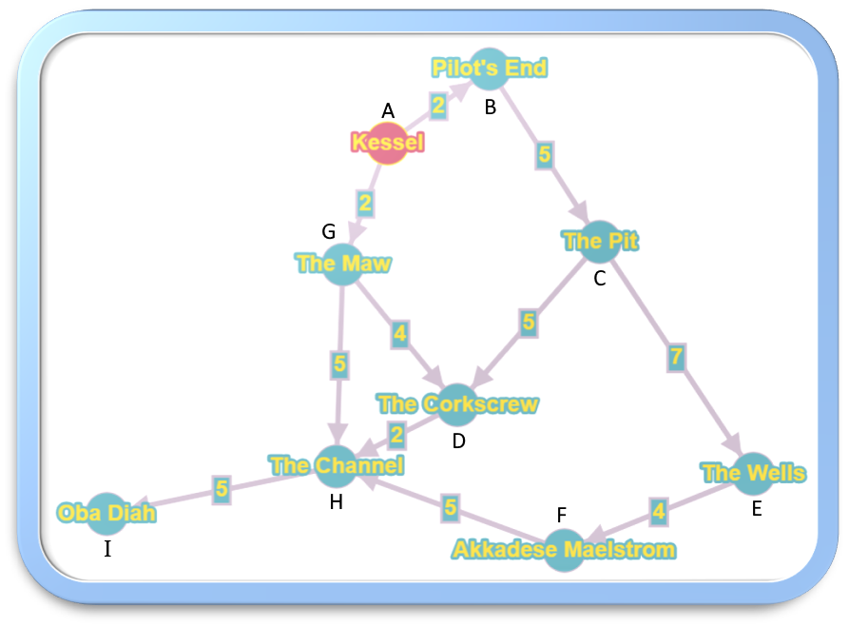

Find the shortest path from vertex "Kessel" to vertex "Oba Diah" using Dijkstra's algorithm.

Weights provided are given in parsecs, a unit used to measure astronomical distances.

Labels are provided at each vertex for better convenience while running Dijkstra's algorithm.

Solution:

Han Solo's record-breaking flight through the Kessel Run followed this route:

Kessel (A) -> 2 -> The Maw (G) -> 5 -> The Channel (H) -> 5 -> Oba Diah (I)

This path resulted in a total travel distance of about 12 parsecs.

Steps of Dijkstra's algorithm:

|  |  |  |  |  |  |  |  |  |  |  |  |  |  |
| --- | --- | --- | --- | --- | --- | --- | --- | --- | --- | --- | --- | --- | --- |
| S | V - S | u | v | D[v] | D[u] + G.w(u, v) | D[B] | D[C] | D[D] | D[E] | D[F] | D[G] | D[H] | D[I] |
| A | B, C, D, E, F, G, H, I | B | C | ∞ | 2 + 5 = 7 | 2 | ∞ | ∞ | ∞ | ∞ | 2 | ∞ | ∞ |
| A, B | C, D, E, F, G, H, I | G | D | ∞ | 2 + 4 = 6 | 2 | 7 | ∞ | ∞ | ∞ | 2 | ∞ | ∞ |
| A, B, G | C, D, E, F, H, I | G | H | ∞ | 2 + 5 = 7 | 2 | 7 | 6 | ∞ | ∞ | 2 | ∞ | ∞ |
| A, B, G | D, C, E, F, H, I | D | H | 7 | 6 + 2 = 8 | 2 | 7 | 6 | ∞ | ∞ | 2 | 7 | ∞ |
| A, B, G, D | C, E, F, H, I | C | D | 6 | 7 + 5 = 12 | 2 | 7 | 6 | ∞ | ∞ | 2 | 7 | ∞ |
| A, B, G, D, C | E, F, H, I | C | E | ∞ | 7 + 7 = 14 | 2 | 7 | 6 | ∞ | ∞ | 2 | 7 | ∞ |
| A, B, G, D, C | E, F, H, I | H | I | ∞ | 7 + 5 = 12 | 2 | 7 | 6 | 14 | ∞ | 2 | 7 | ∞ |
| A, B, G, D, C, H | E, F, I | I |  |  |  | 2 | 7 | 6 | 14 | ∞ | 2 | 7 | 12 |
| A, B, G, D, C, H, I | E, F | E | F | ∞ | 14 + 4 = 18 | 2 | 7 | 6 | 14 | ∞ | 2 | 7 | 12 |
| A, B, G, D, C, H, I, E | F | F | H | 7 | 18 + 5 = 23 | 2 | 7 | 6 | 14 | 18 | 2 | 7 | 12 |
| A, B, G, D, C, H, I, E, F |  |  |  |  |  | **2** | **7** | **6** | **14** | **18** | **2** | **7** | **12** |

Exercise 2: Minimally Span Where No Tree Has Spanned Before

Given the following weighted, undirected graph:

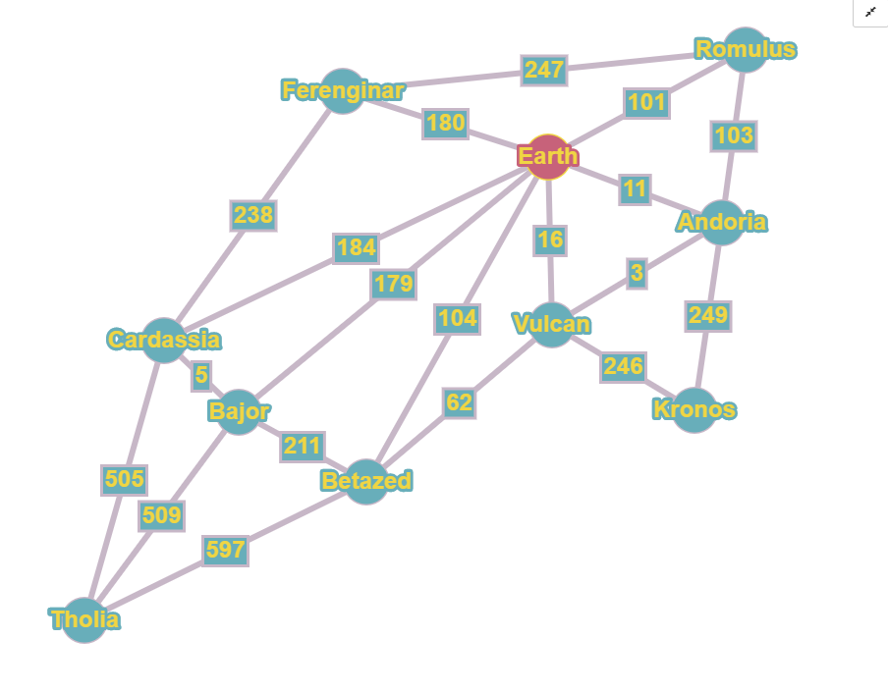

Find the Minimum Spanning Tree using Kruskal's algorithm.

Weights provided are given in light-years, a unit used to measure astronomical distances.

Graph is not to scale.

Solution:

The Minimum Spanning Tree has a total weight of 1,292 light-years:

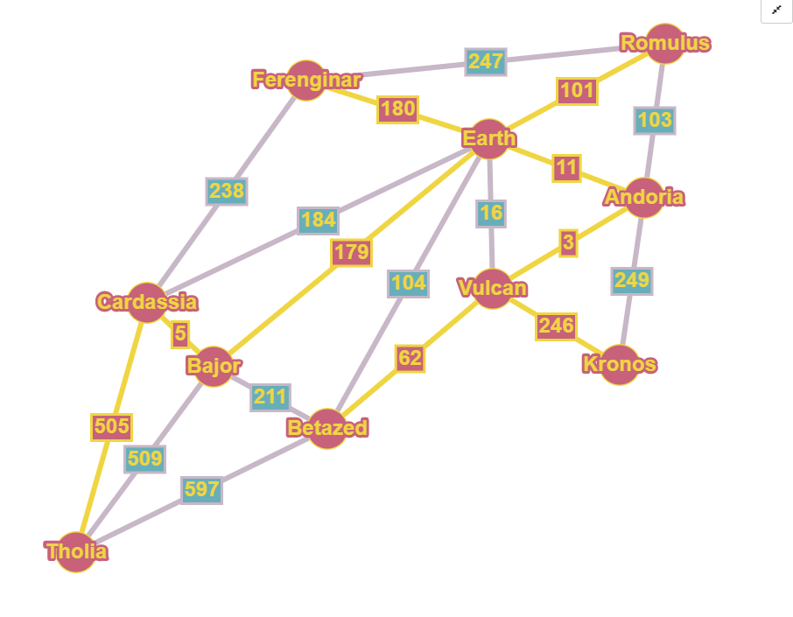

Steps of Kruskal's algorithm:

|  |  |  |  |
| --- | --- | --- | --- |
| Vulcan  Andoria  3 | Bajor  Cardassia  5 | Earth  Andoria  11 | Earth  Vulcan  16 |
| Vulcan  Betazed  62 | Earth  Romulus  101 | Andoria  Romulus  103 | Earth  Betazed  104 |
| Earth  Bajor  179 | Earth  Ferenginar  180 | Earth  Cardassia  184 | Bajor  Betazed  211 |
| Ferenginar  Cardassia  238 | Vulcan  Kronos  246 | Ferenginar  Romulus  247 | Andoria  Kronos  249 |
| Tholia  Cardassia  505 | Bajor  Tholia  509 | Betazed  Tholia  597 |  |

Exercise 3: One Does Not Simply Traverse A Graph

Given the following unweighted, undirected graph:

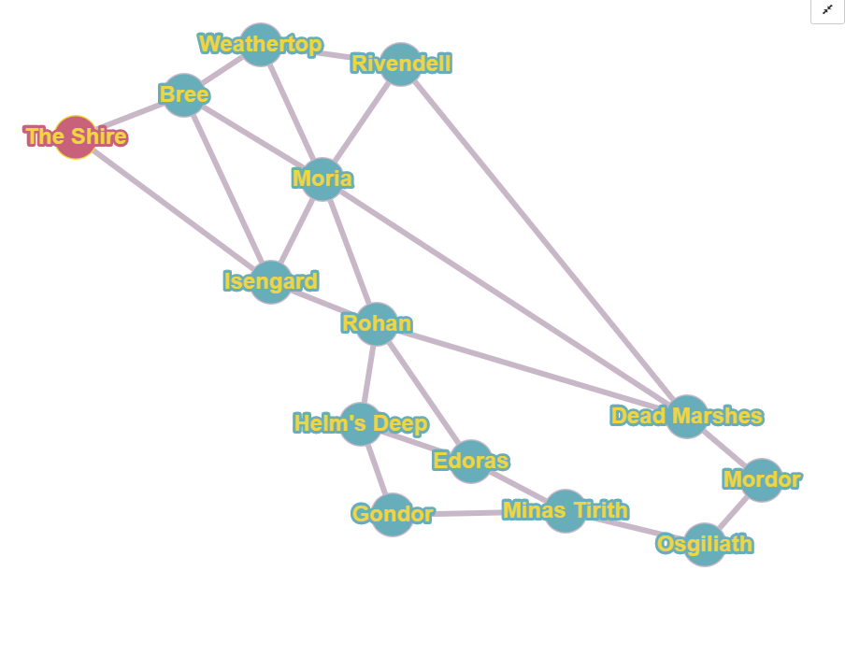

Find the BFS tree/forest and the DFS tree/forest both starting from vertex "The Shire."

Solution:

The result of BFS will be the following tree:

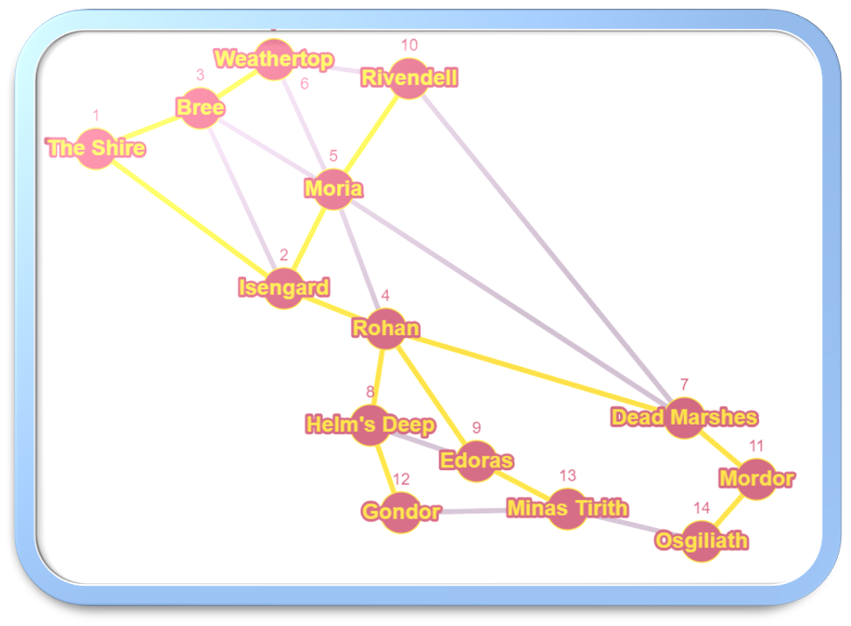

The result of DFS will be the following tree:

